I chose a data set about the number of penguins in New Zealand from 2000-2007 and then forecast the number out 10-30 months. Upon searching for how many penguins there are today, I found that there are 18 species of penguins in New Zealand. This data is just a general number of penguins and not any certain species. I also could not find out how many penguins there are for the time of the forecast to determine if it was accurate.

First up was the SES graph for a forecast of 10 months

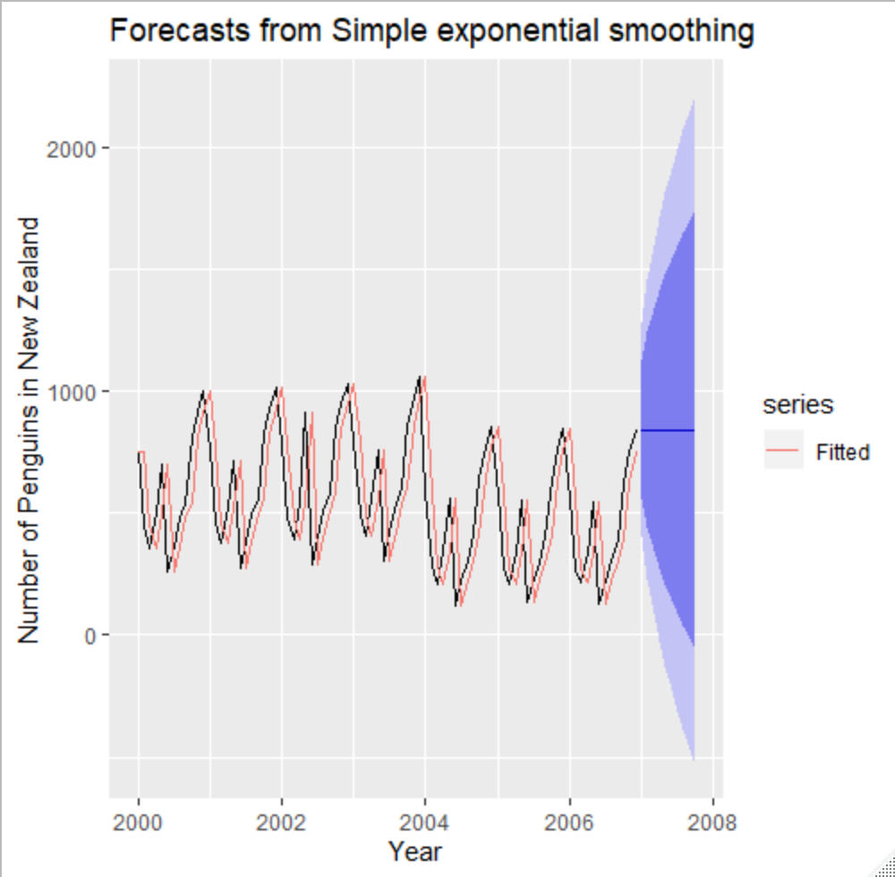

Next graph depicts Holt’s and damped Holt’s methods for 20 months

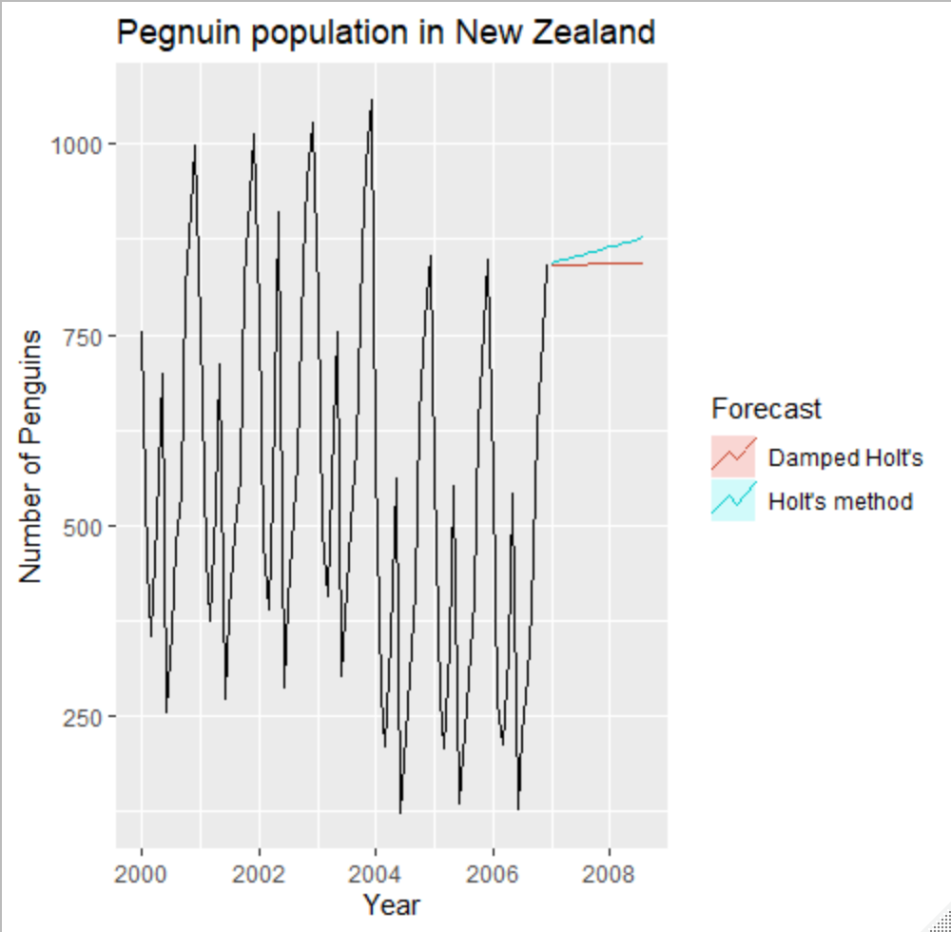

I do not believe that this is the best choice for forecasting because of the data having a strong seasonality.

The next graph shows Holt-Winters additive and multiplicative forecast method

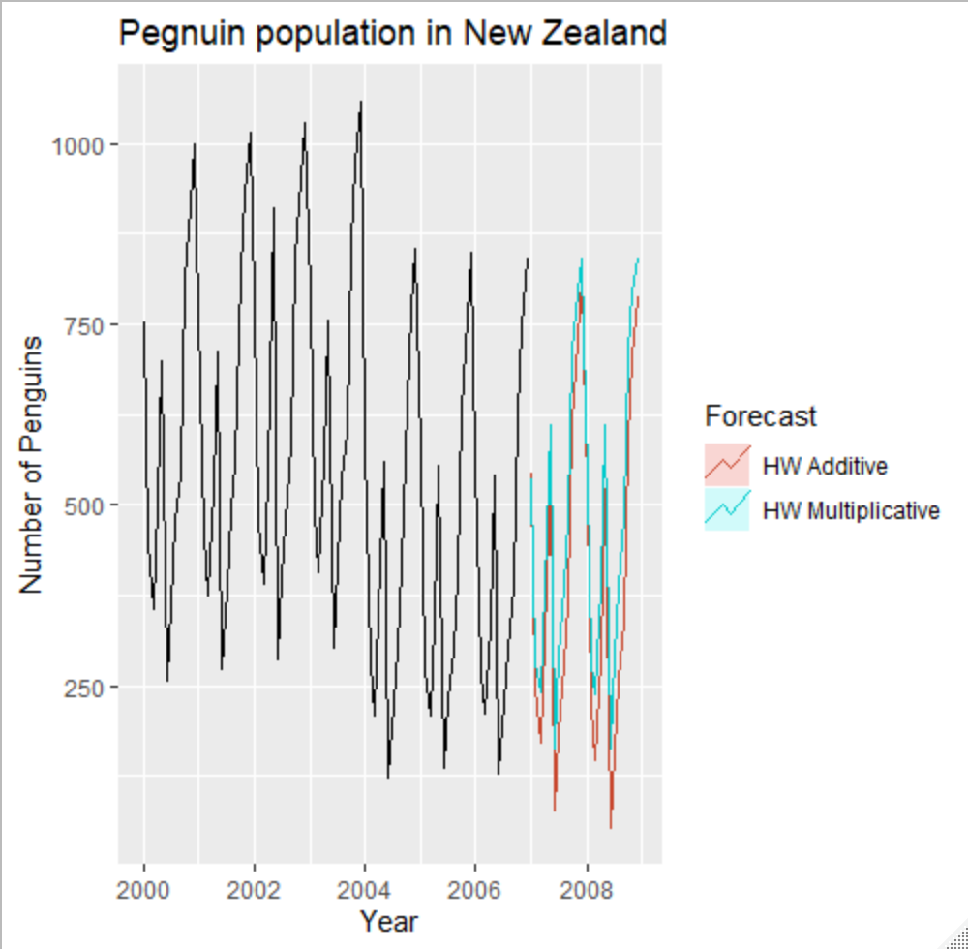

This looks to be a better option for forecasting compared to the Holt method

Next graph shows Holt-Winters multiplicative damped forecast

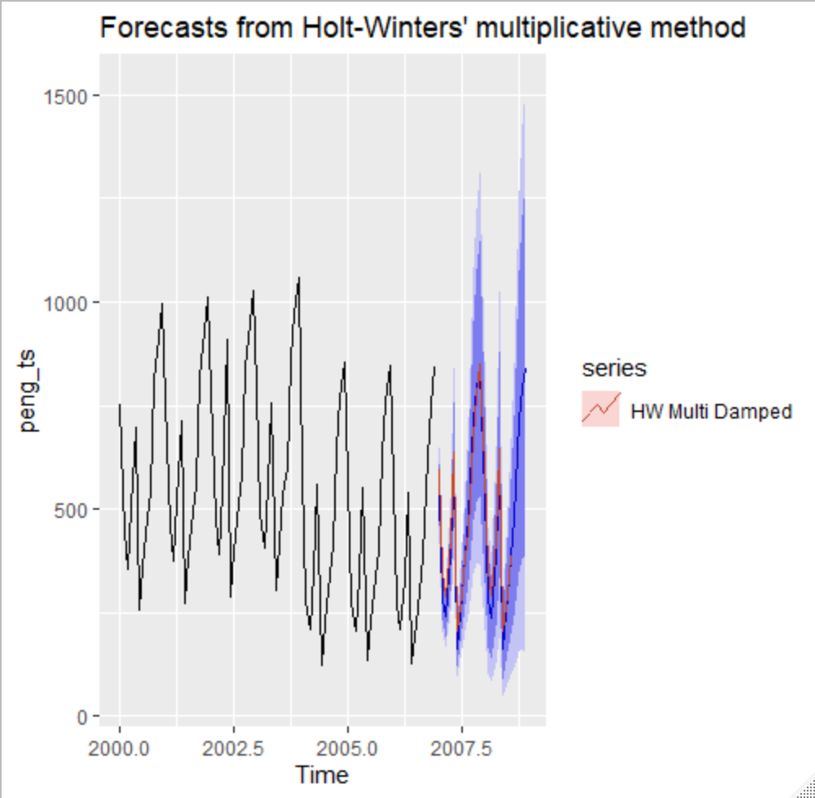

Damped Holt-Winters looks to be the best graph for forecasting the data. Based on the previous year’s data I would expect to see an upward trend and this graph shows that.

The nest graph is an ETS graph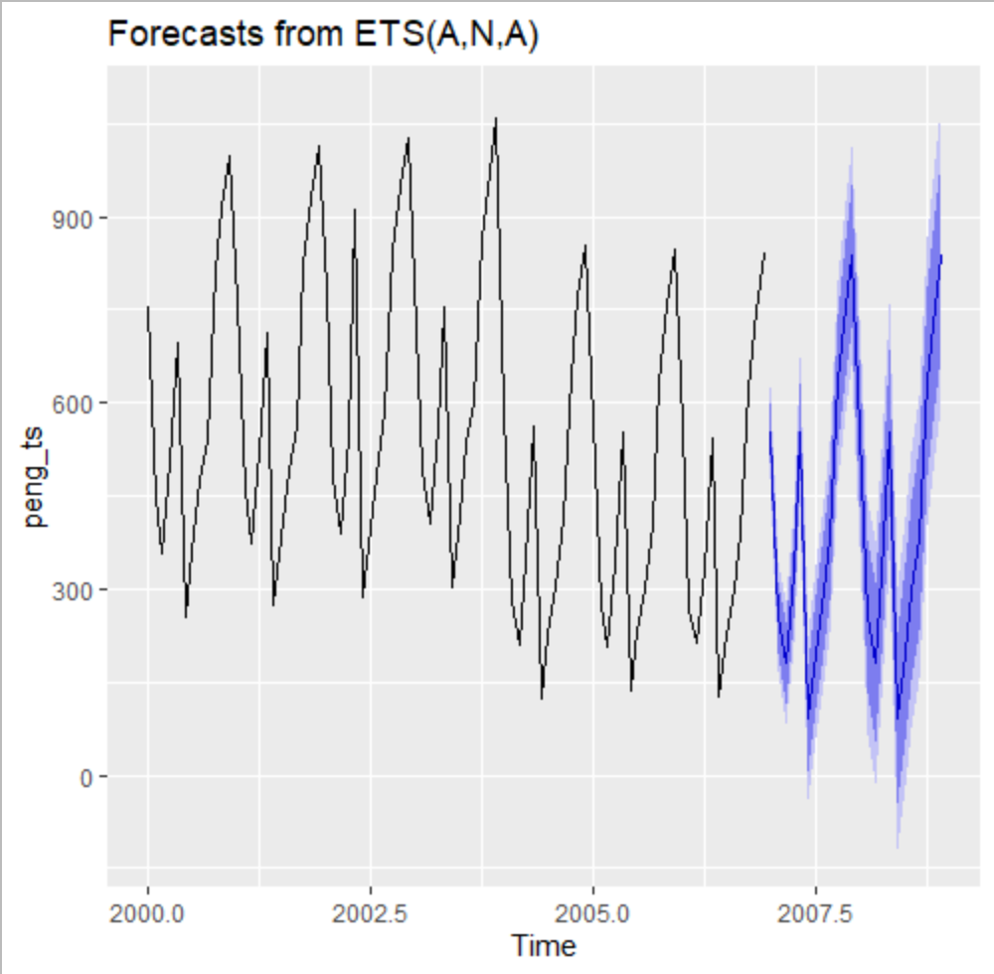

This graph is quite accurate also and shows what I would expect to see just like the Damped HW method

The following are the accuracies of all the models

> accuracy(peng_ses)

ME RMSE MAE MPE MAPE MASE ACF1

Training set 1.059853 219.3123 182.4212 -15.91689 48.95196 3.662668 0.03205628

> accuracy(peng_holt)

ME RMSE MAE MPE MAPE MASE ACF1

Training set 2.099025 220.7672 184.5829 -15.96077 49.28461 3.70607 0.01428725

> accuracy(peng_holt_damped)

ME RMSE MAE MPE MAPE MASE ACF1

Training set 3.000032 220.9141 185.0605 -15.72608 49.32836 3.71566 0.01387152

> accuracy(peng_hw_add)

ME RMSE MAE MPE MAPE MASE ACF1

Training set -1.100667 34.19631 20.09419 0.1008138 5.01495 0.4034528 0.004361025

> accuracy(peng_hw_mult)

ME RMSE MAE MPE MAPE MASE ACF1

Training set 4.217291 47.20862 36.33497 -1.378065 8.067161 0.7295365 0.3311085

> accuracy(peng_hw_mult_damp)

ME RMSE MAE MPE MAPE MASE ACF1

Training set -0.7629356 39.80349 30.82889 -0.801289 7.642897 0.618985 0.1185171

> accuracy(peng_ets)

ME RMSE MAE MPE MAPE MASE ACF1

Training set -3.224824 34.12017 18.79272 -0.4834294 4.604033 0.3773218 -0.003763216

Looks like the ETS forecast is the most accurate for this time series data based on RMSE values at 34.12